1. Exercise 2: Screenshot showing ‘mynewcollection’ in the Solr Web Interface

1. Exercise 3: Screenshot showing successful data ingestion messages in the terminal

1. Exercise 5: Query for products in the ‘Electronics’ category.

1. Exercise 6 & 7:

Select Category and Price for ID = 2:

Price > 25

Sort Ascending

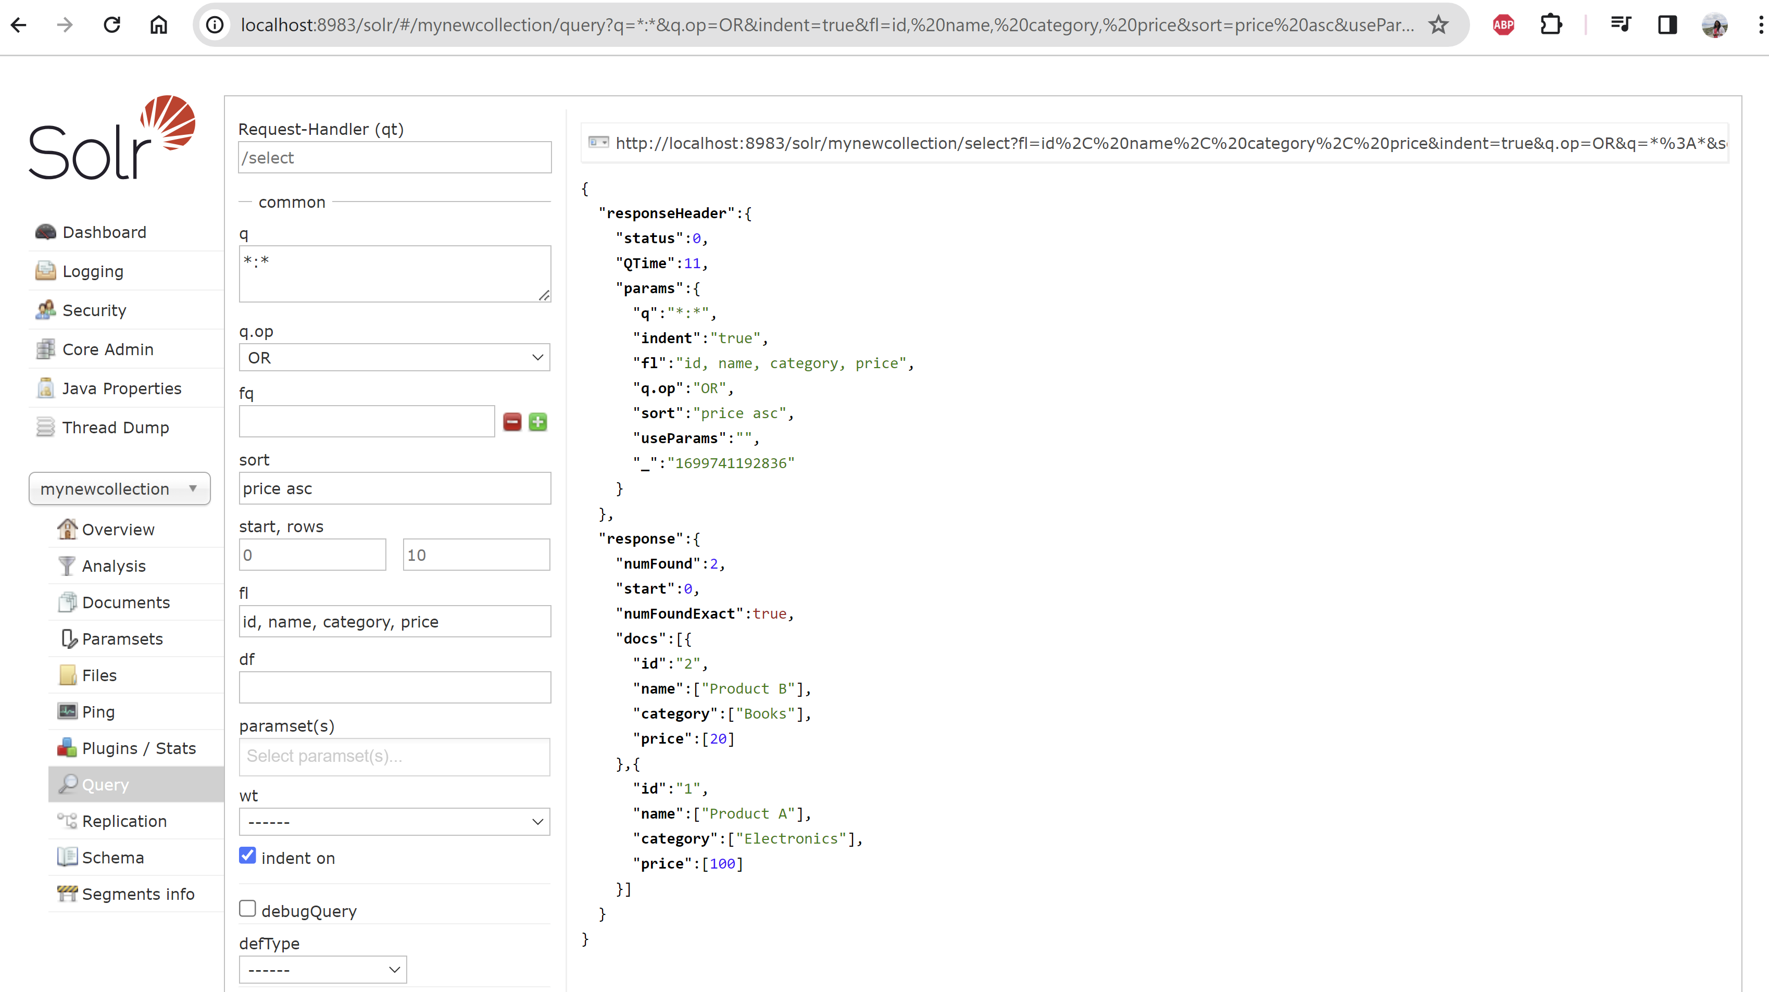

1. Custom JSON Data

SECOND COLLECTION

Creation & JSON

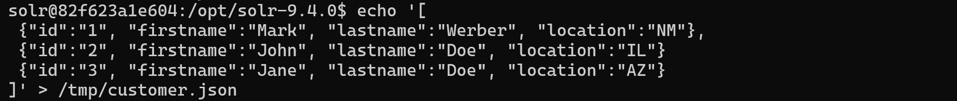

There was an error in this script. I missed a “,” in the 2nd row which caused only 2 rows to be inserted. I added the 3rd row again as following:



Querying gives the following json with the 3 rows.

Web Query

Sort by id descending

